**Name- ARYAN**

**Sap id- 500120565**

**Batch- 2(Devops)**

**Lab Exercise 1- Docker Fundamental Commands**

**Objective**

Learn and practice the fundamental Docker CLI commands to:

* Manage images and containers
* Understand container lifecycle
* Build and run applications using Docker

**1. Setup**

**Prerequisites**

* Docker installed on your system  
  (Check using: docker --version)
* Internet access to pull images

**2. Basic Docker Commands**

**Step 1: Verify Installation**

docker –version

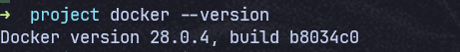

docker info

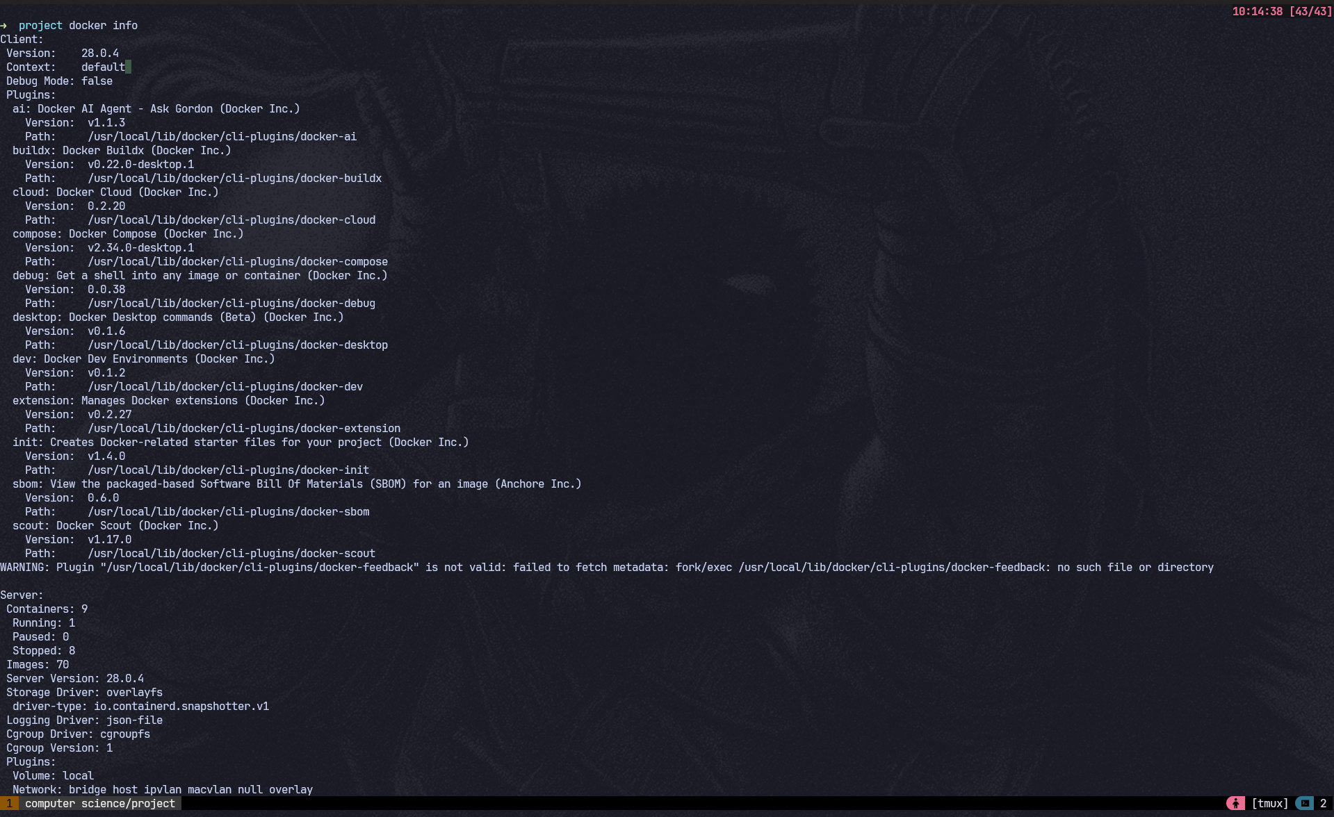

*Expected Output:* Docker version and system details.

**Step 2: Pull an Image from Docker Hub**

docker pull ubuntu:latest

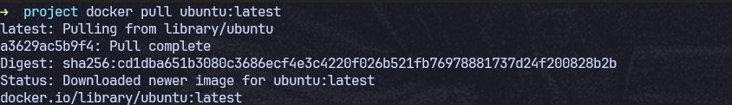

*Explanation:* Downloads the latest Ubuntu image from Docker Hub.

Check available images:

docker images

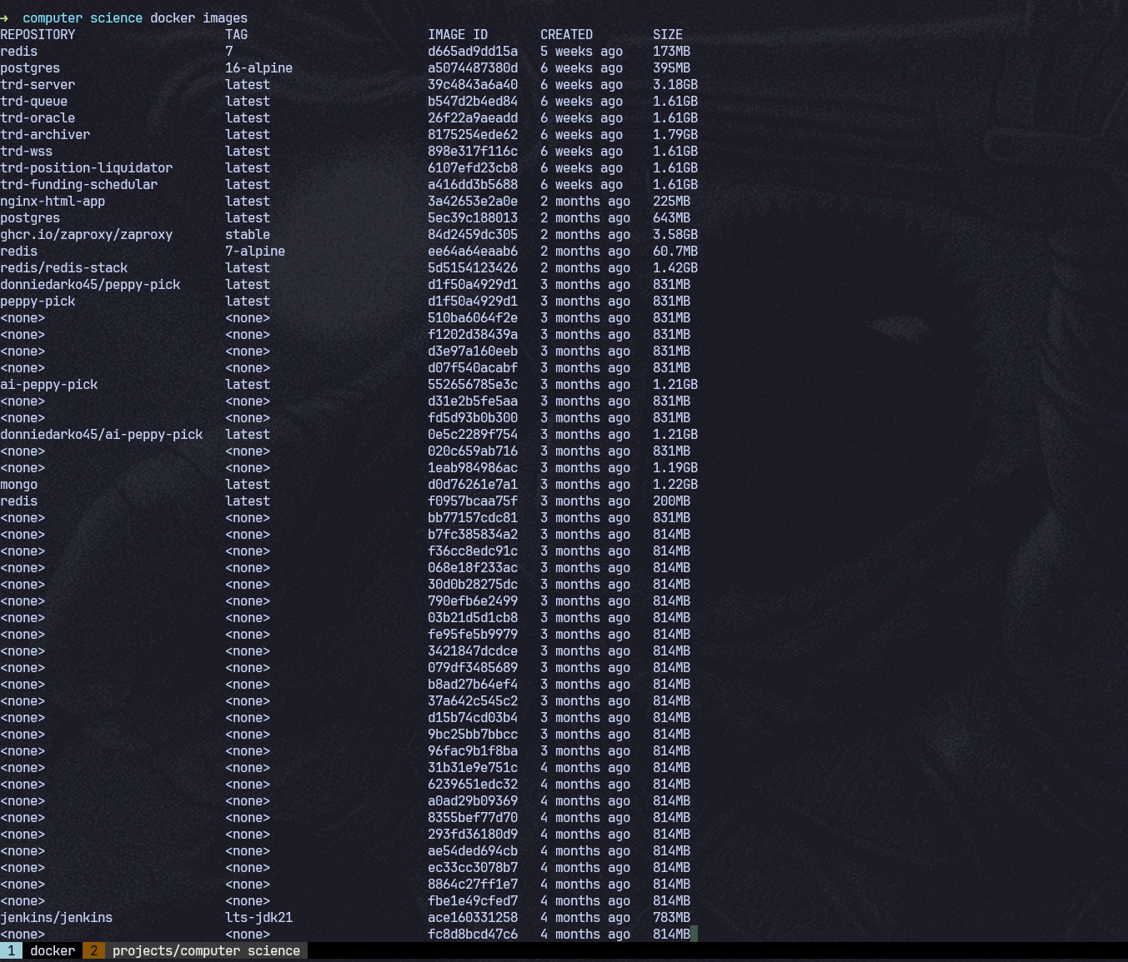

**Step 3: Run a Container**

Run Ubuntu interactively:

docker run -it --name myubuntu ubuntu bash

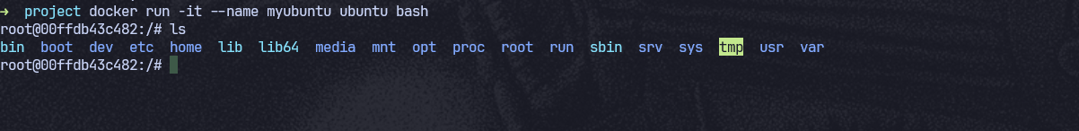

Now you’re inside a running container (prompt will change).

Exit:

Exit

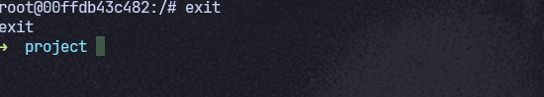

**Step 4: List Containers**

* Show running containers:

docker ps



* Show all containers (including stopped):

docker ps -a

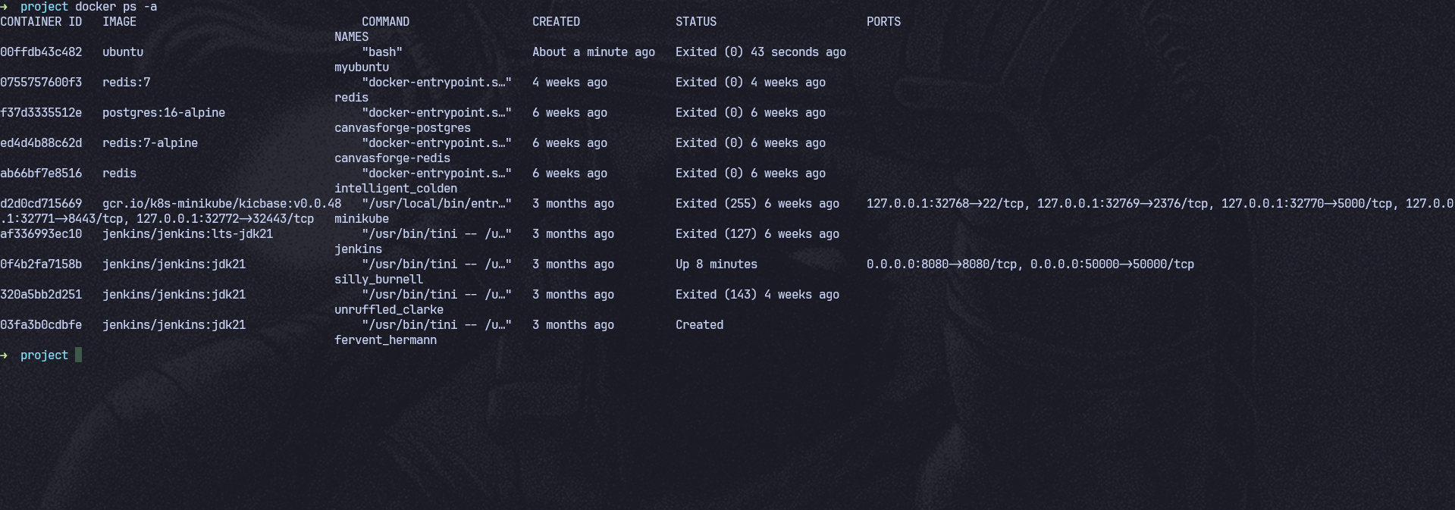

**Step 5: Start / Stop / Remove Containers**

# Start a stopped container

docker start <container_id>

# Stop a running container

docker stop <container_id>

# Remove a container

docker rm <container_id>

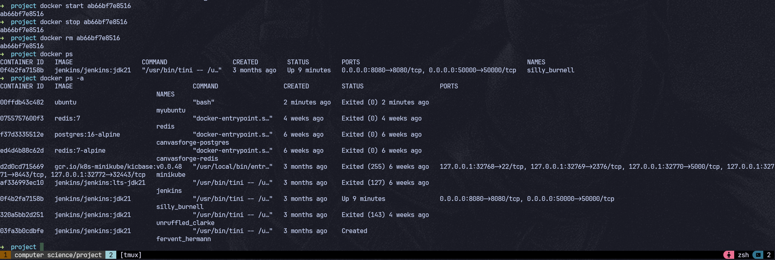

*Tip:* Use docker ps -a to get container IDs.

**Step 6: Remove Images**

docker rmi ubuntu:latest

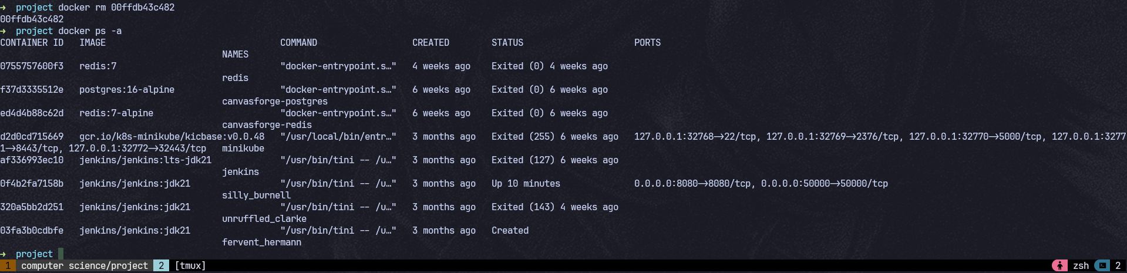

*Note:* You must stop and remove all containers using that image first.